**Wiring Diagrams and pictures of actual experiment setup**

1. Square FSR

The wiring diagrams

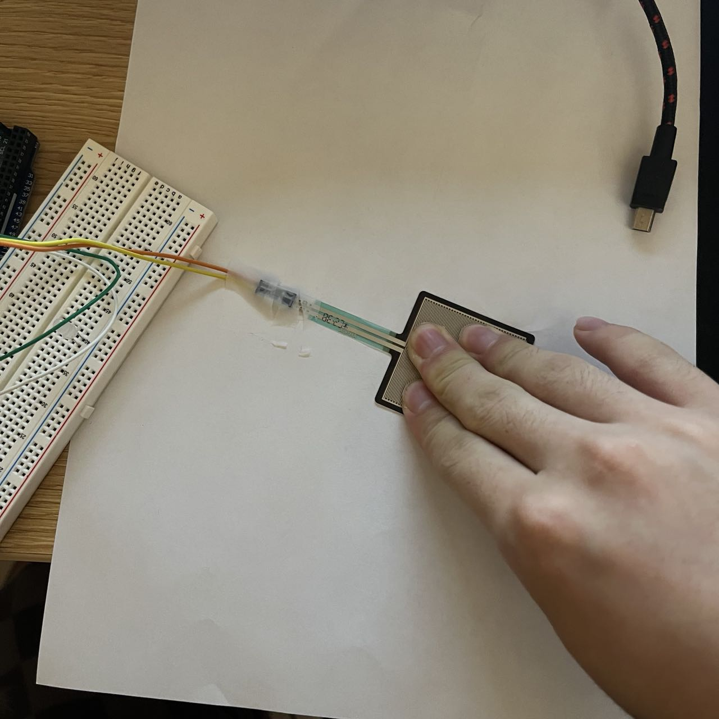

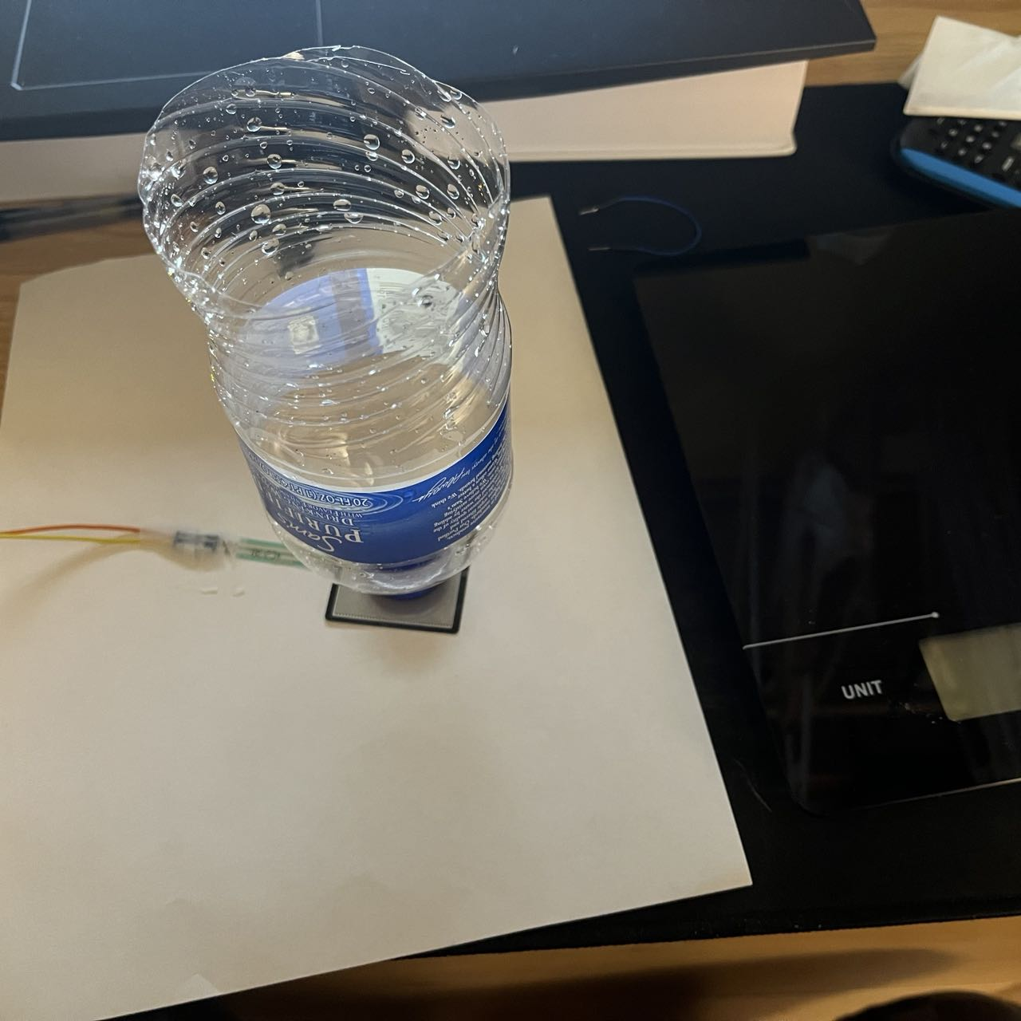

1. Circular Soft Potentiometer

The wiring diagrams

电脑萤幕画面

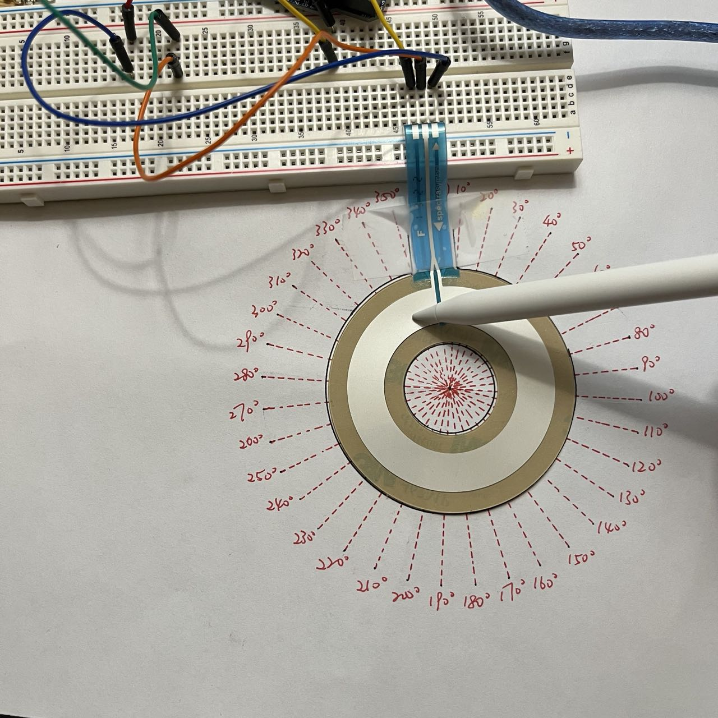

1. long flex/bend sensor

The wiring diagrams

